WALMART SALES DATA

Purposes of The Project

Single table analysis

The major aim of this project is to gain insight into the sales data of store to understand the different

* PRODUCT

1. How many unique product lines does the data have?



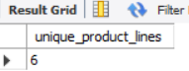

1. What is the most common payment method? 

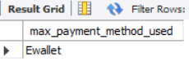

1. What is the most selling product line? 

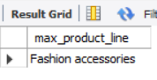

1. What is the total revenue by month?  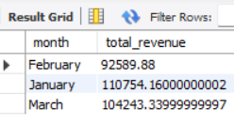
2. What month had the largest COGS?  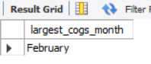
3. What product line had the largest revenue?  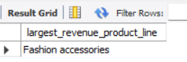
4. What is the city with the largest revenue?  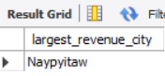
5. What product line had the largest VAT?  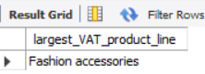
6. Fetch each product line and add a column to those product line showing "Good"," Bad" good if its greater than the Average sales? 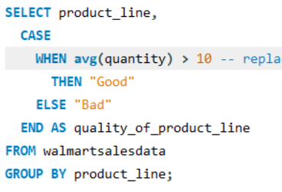 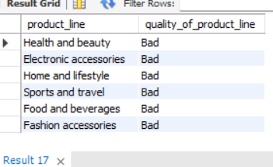
7. Which branch sold more products than average product sold?  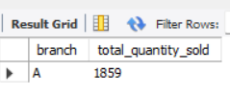
8. What is the most common products than average product sold? 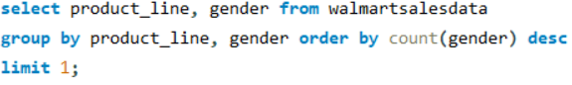 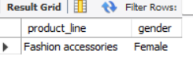
9. What is the average ratting of each product line? 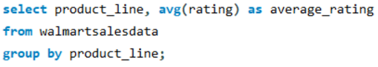 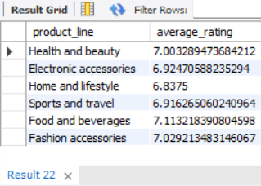

* SALES

1. Number of sales made in each time of the day per weekday? 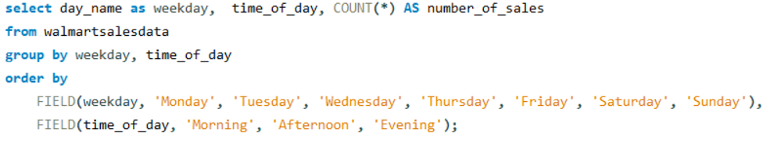 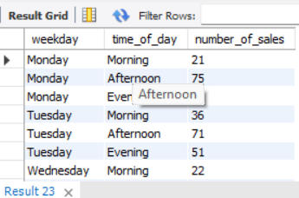

2. Which of the customer types brings the most revenue? 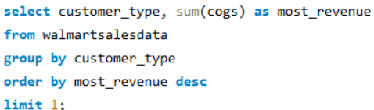 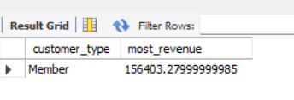

3. Which city has the largest tax percent/ VAT (Value Added Tax)?  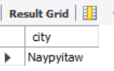

4. Which customer type pays the most in VAT?  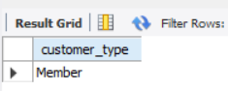

* CUSTOMER

1. How many unique customer types does the data have?  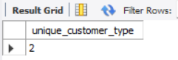

2. How many unique payment methods does the data have?  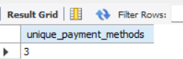

3. What is the most common customer type?  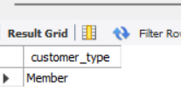

4. Which customer type buys the most?  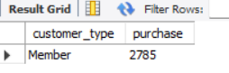

5. What is the gender of most of the customers? 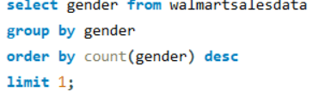 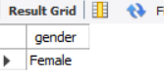

6. What is the gender distribution per branch? 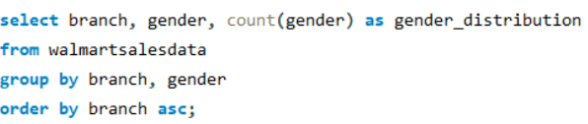 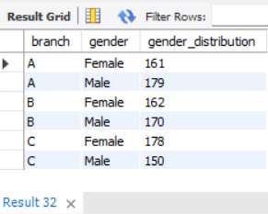

7. Which time of the day do customers give most ratings? 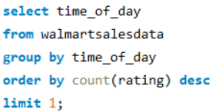 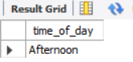

8. Which time of the day do customers give most ratings per branch? 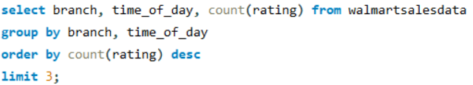 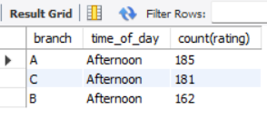

9. Which day of the week has the best avg ratings? 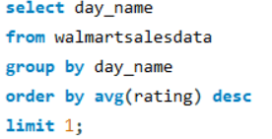 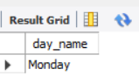

10. Which day of the week has the best average ratings per branch? 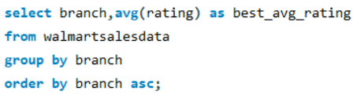 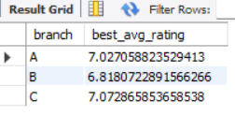

**Key Conclusions from Walmart Sales Data Analysis**

1. **Geographical Spread**:
   * The data includes multiple unique cities, indicating a broad distribution of sales.
2. **Branch Locations**:
   * Each branch is located in a specific city, revealing the geographical distribution of Walmart outlets.
3. **Product Variety**:
   * The data features several unique product lines, showcasing a diverse product range.
4. **Customer Preferences**:
   * The most common payment method reflects preferred transaction methods among customers.
   * The most popular product line indicates the top-selling category.
5. **Revenue Trends**:
   * Monthly revenue analysis identifies peak sales periods.
   * The city with the largest revenue and the month with the highest COGS provide insights for financial planning.
6. **Product Performance**:
   * High-revenue product lines and those with significant VAT contributions highlight key performers.
   * Product lines labeled as "Good" or "Bad" based on average sales offer a performance overview.
7. **Branch Performance**:
   * Identifying branches with above-average sales helps recognize high-performing locations.
8. **Demographic Insights**:
   * The most common product lines by gender aid in targeted marketing.
   * Average ratings per product line provide customer satisfaction insights.